Using Compfight to find Creative Commons Images
Note: Compfight is both a source and a search tool.
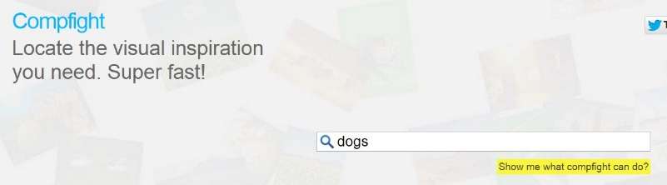
- Enter a search in the search box.

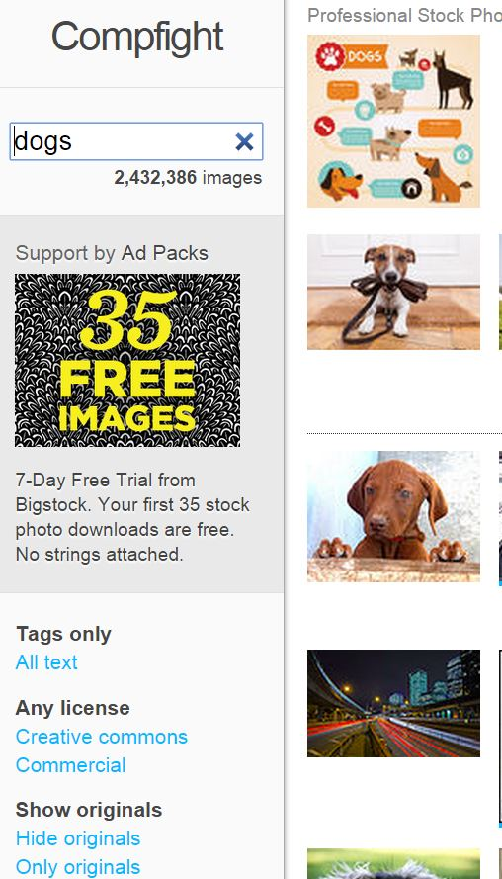
- Once the images have loaded, use the left-side navigation options to select only images that have a Creative Commons license.

- Select an image that falls below the line. Photos above the line are stock photos that require payment.
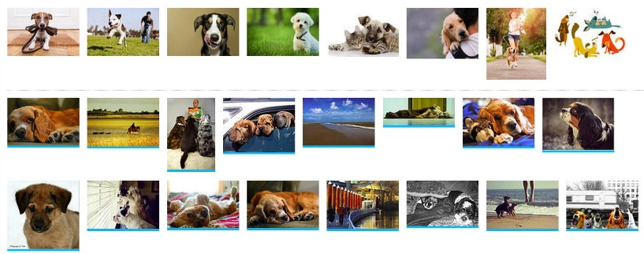

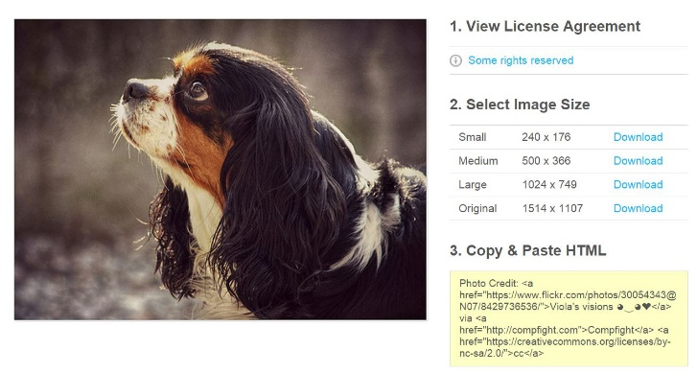
- Click on “some rights reserved” to view the license to confirm that the photo may be used.

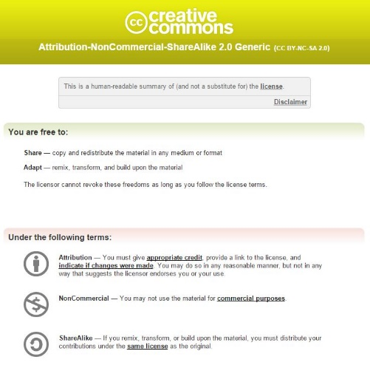
- To insert the photo into a website, go back to the photo and
  - Select the image size you want and download it to your Picture file.
  - Insert the picture into your website, blog, etc.
  - Go back to the Compfight photo and copy the HTML embed code.
  - Go to your website and insert the HTML code. Position it under the photo.

- You can also use Compfight to include photos on to fair-type backboards, WORD documents and PowerPoints.
  - Find your image as per the instructions above
  - Download the image and insert it into your Powerpoint or WORD document.
  - Insert a text box and attribute with the title of the photo if given, photographer, source, license and URL. You’ll find this information in the embed code. If inserting into a PPT, you may link the URL to the license.
Viola’s visions
Source: Compfight; CC-BY-NC-SA-2.0
https://www.flickr.com/photos/30054343@N07/8429736536

