Imagecodr.org
Use Imagecodr.org to create an all in one photo that includes the license information that may be embedded into a website. The photo must come from Flickr.
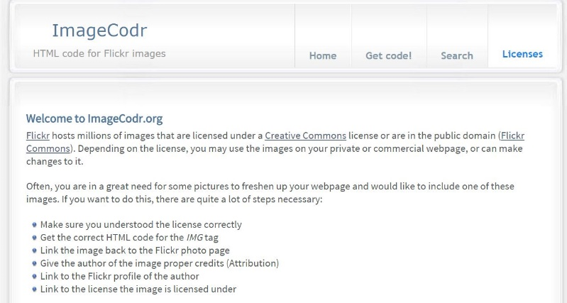
yh0
- Go to imagecodr.org and click on the “Search” button.

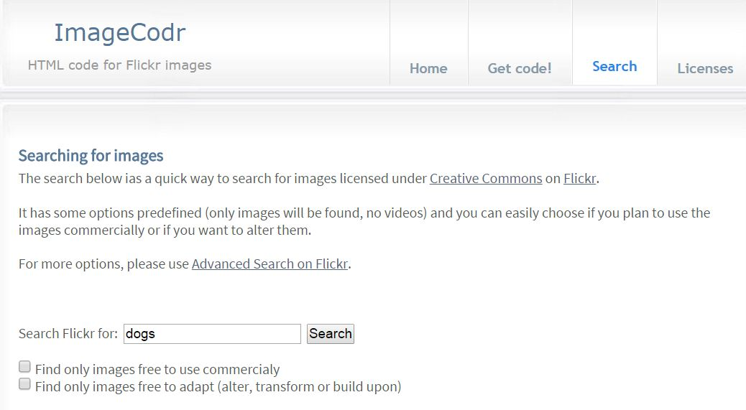
- Enter your search in the search box. This search will only find images.

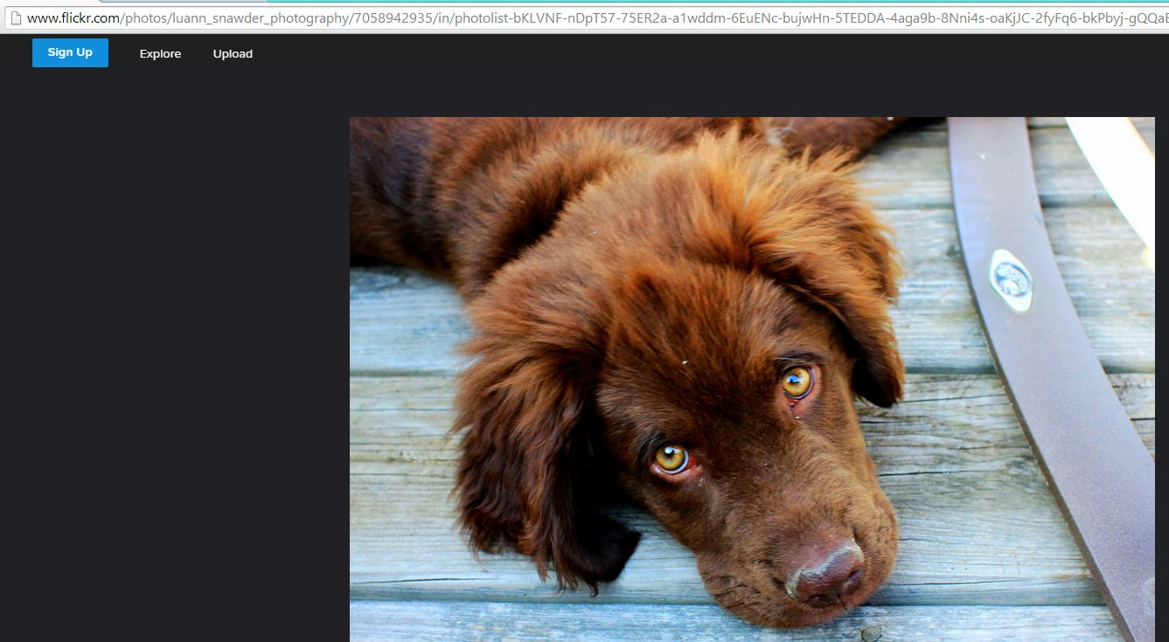
- Click on the image you want and copy the URL at the top of the page.

- Go back to Imagecodr and select “Get Code”.

- Paste the URL into the search box and click on “Submit”.
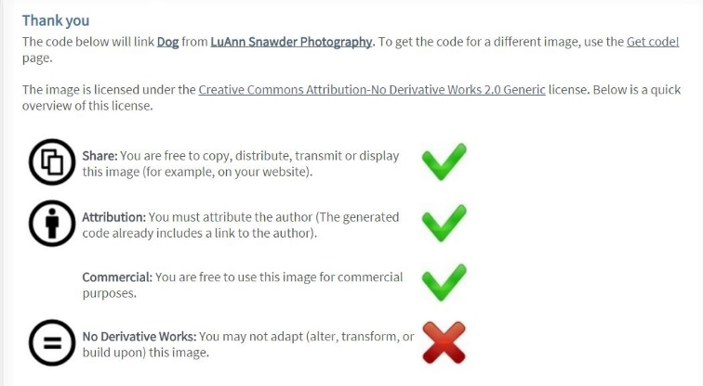

- Note the license specifics.

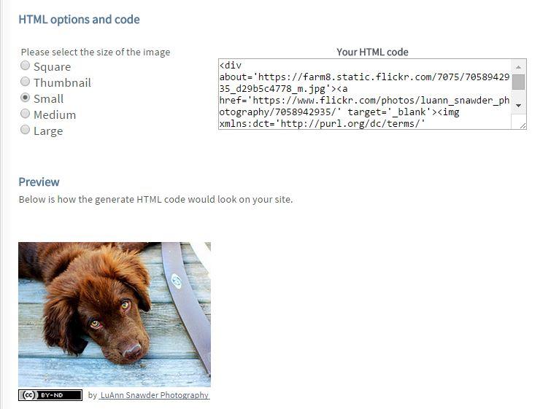
- Select the size of the image you would like and copy the embed code.

- Go to your website and paste the embedded URL code in the location you would like it. The photo will appear along with all of the attribution/license information.

Note: Embed code cannot be used in a PPT or WORD document.

